MsSQL Databse:
Step 2: Go to Amazon RDS
- In the top search bar, type RDS and select Amazon RDS.
- Click "Create database".
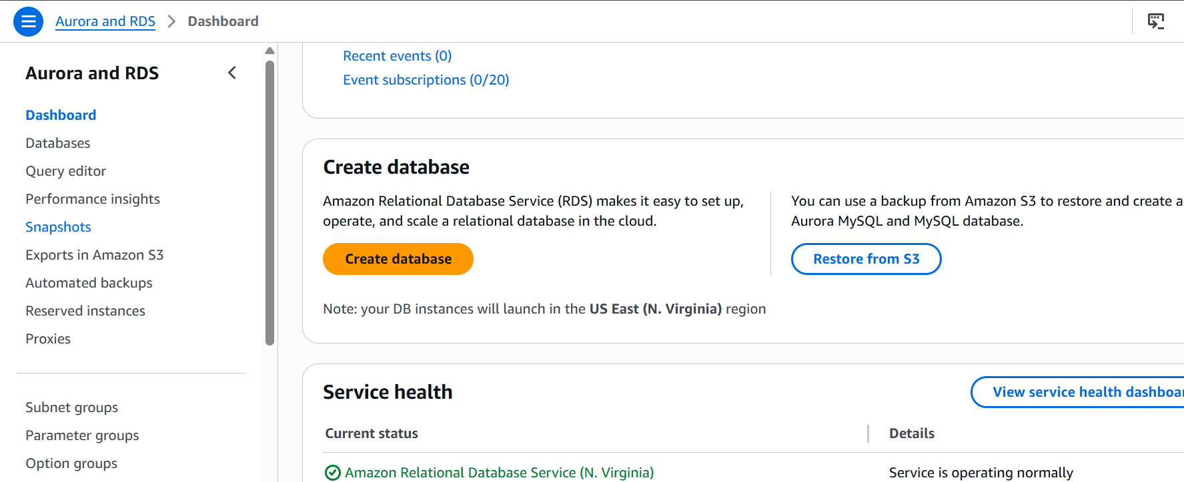

Step 3: Select Database Creation Method
- Choose Standard Create (gives more control but still simple).
- 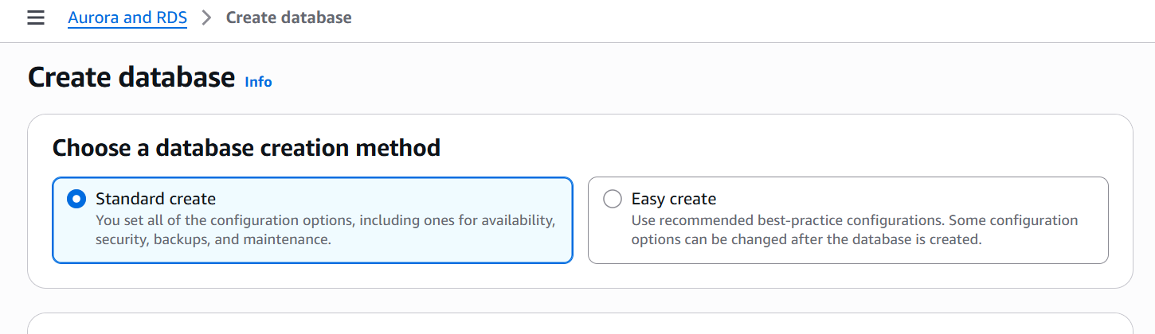
- Engine options:
  - Select Microsoft SQL Server
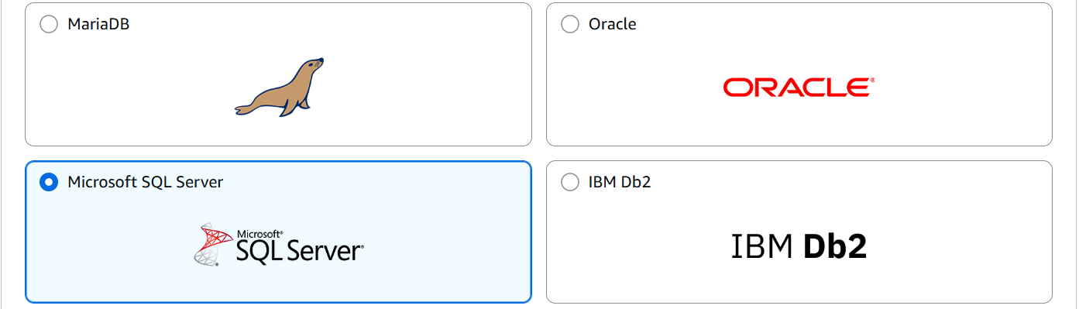
  - Choose an edition:
    - Express – Free for learning (recommended)
    - Web – For web applications
    - Standard/Enterprise – Full features (costs more)
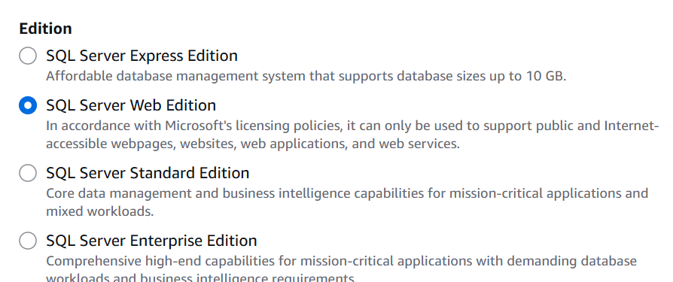
Template :free tier
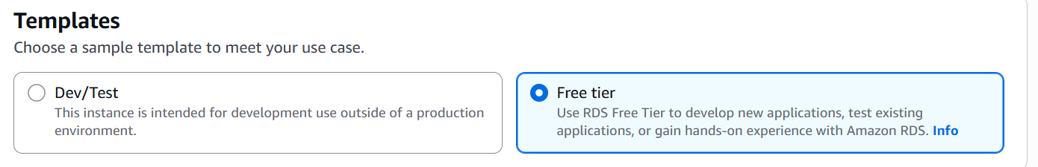
Section 3:settings
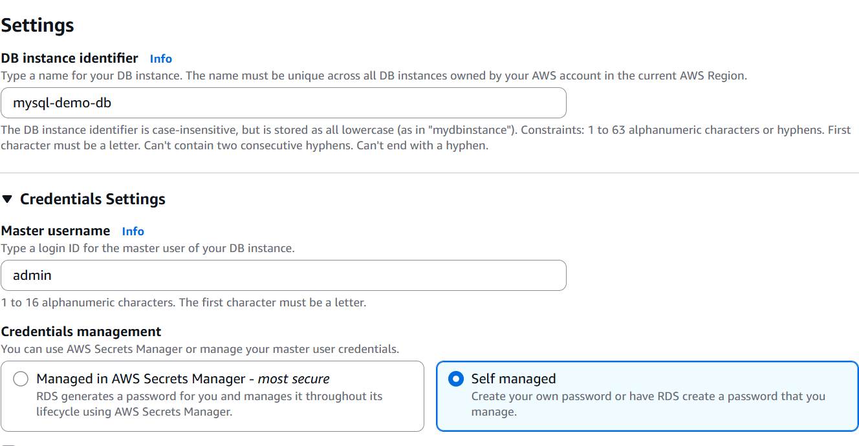Authentication:
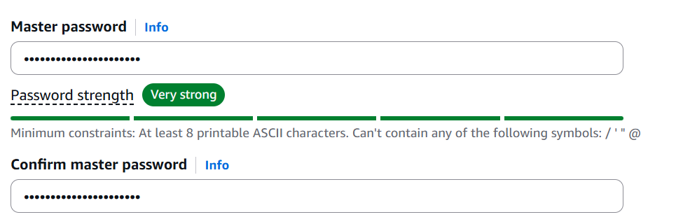
SECTION 4: DB Instance Size
DB instance class db.t3.micro
Storage type General Purpose (SSD)
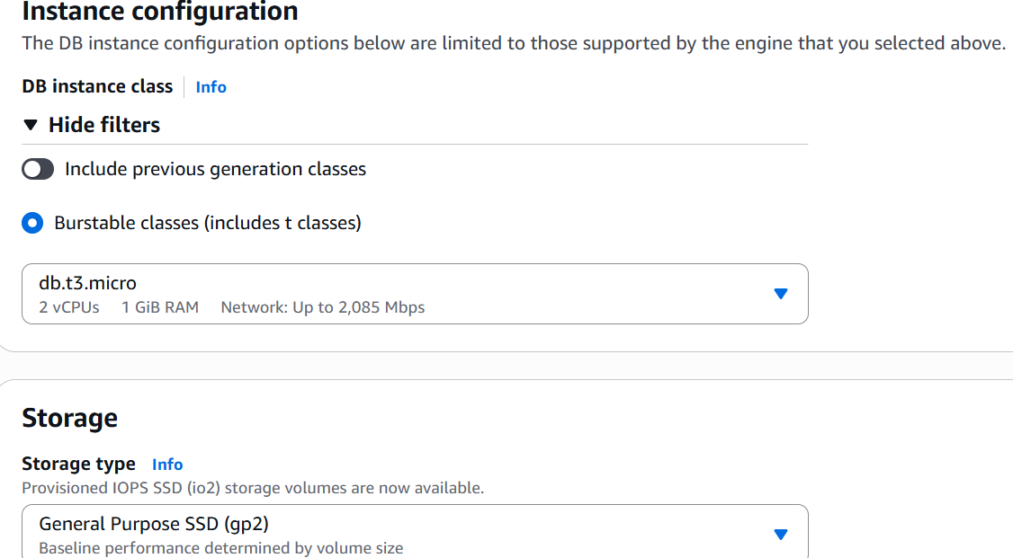
Allocated storage 20 GiB (Free Tier)
Enable autoscaling Unchecked (optional)
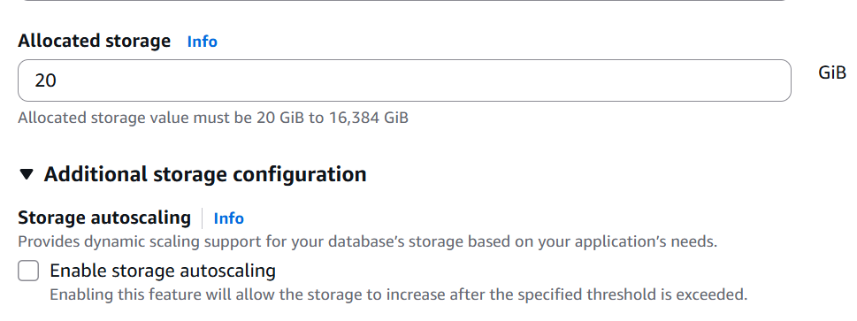
SECTION 5: Connectivity
Virtual Private Cloud (VPC) Default (or create new)
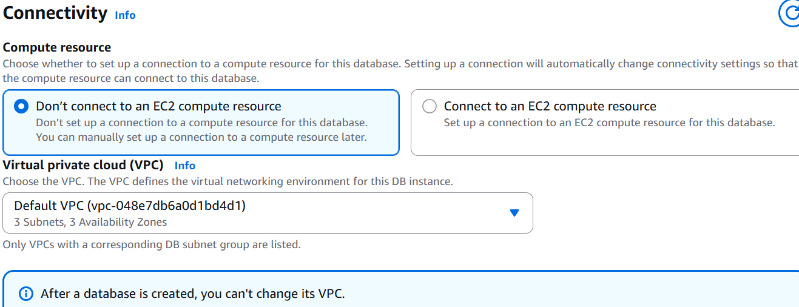
Public access Yes
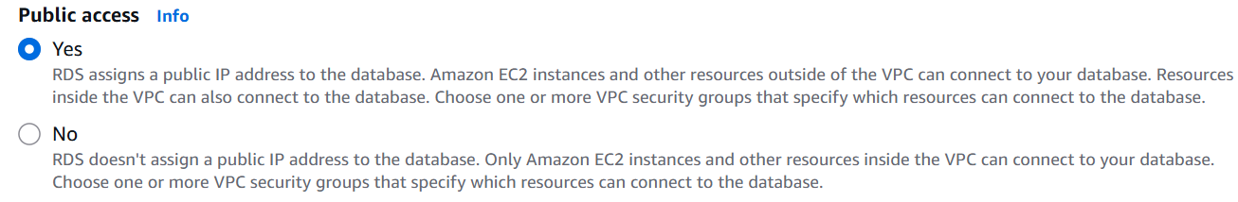
VPC security group Create new or choose default
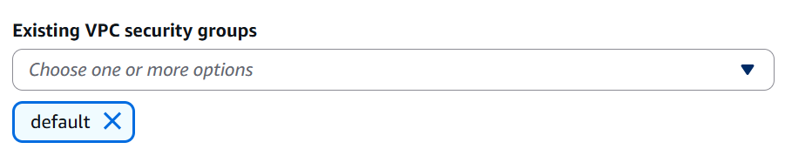
Availability zone No preference
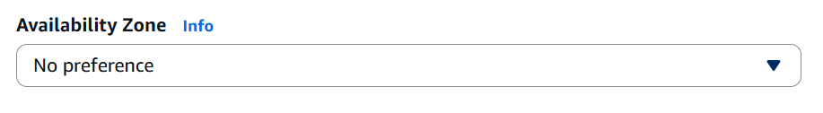
SECTION 6: Database Authentication
Authentication:password
SECTION 7: Additional Configuration
Initial DB name mydb
DB port 1433
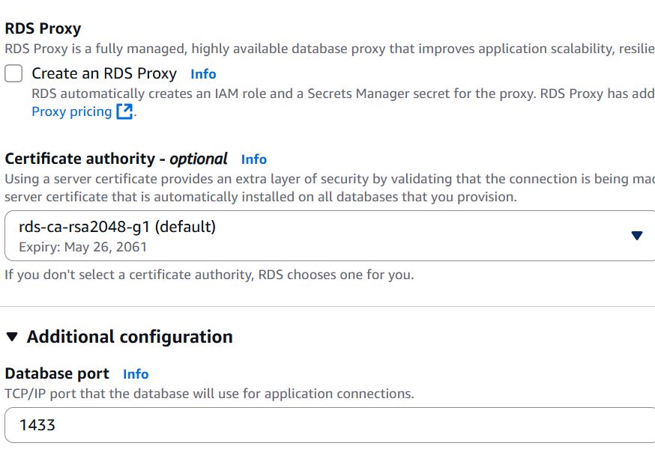
DB parameter group Default
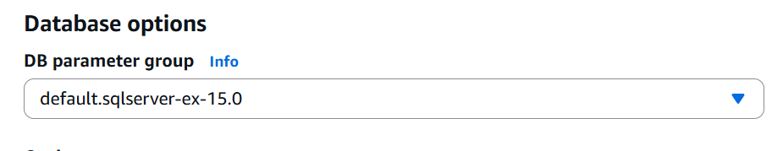
Option group Default
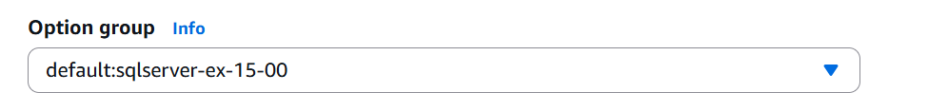
Backup retention 1 day (or 0 for none)
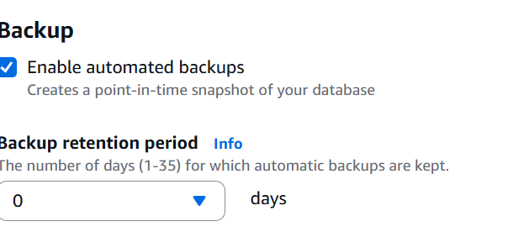
Encryption Default
Monitoring Default or off
Maintenance window Default
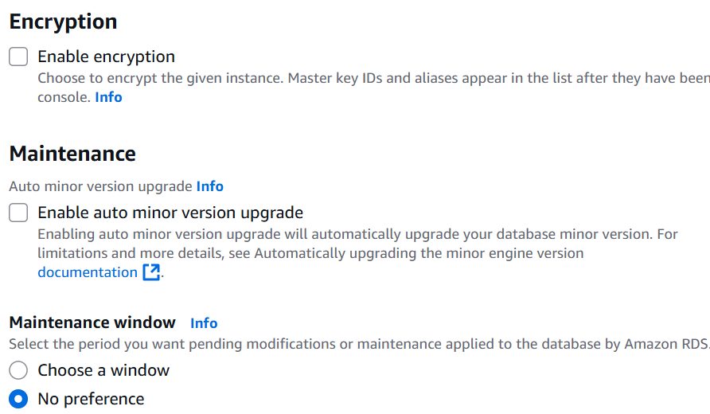

SECTION 8: Create Database
Click "Create Database" at the bottom.
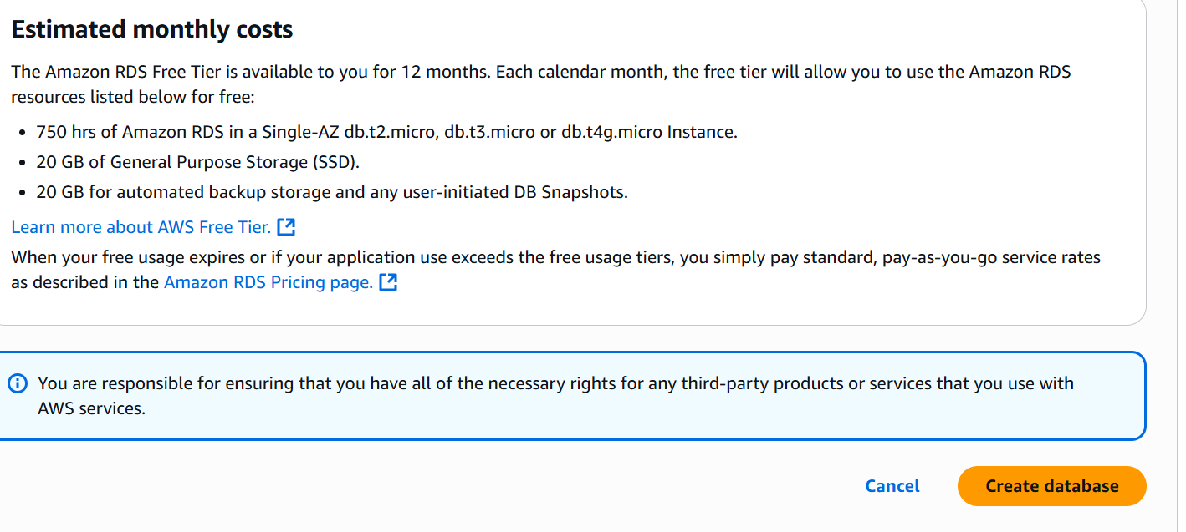
Status : Available

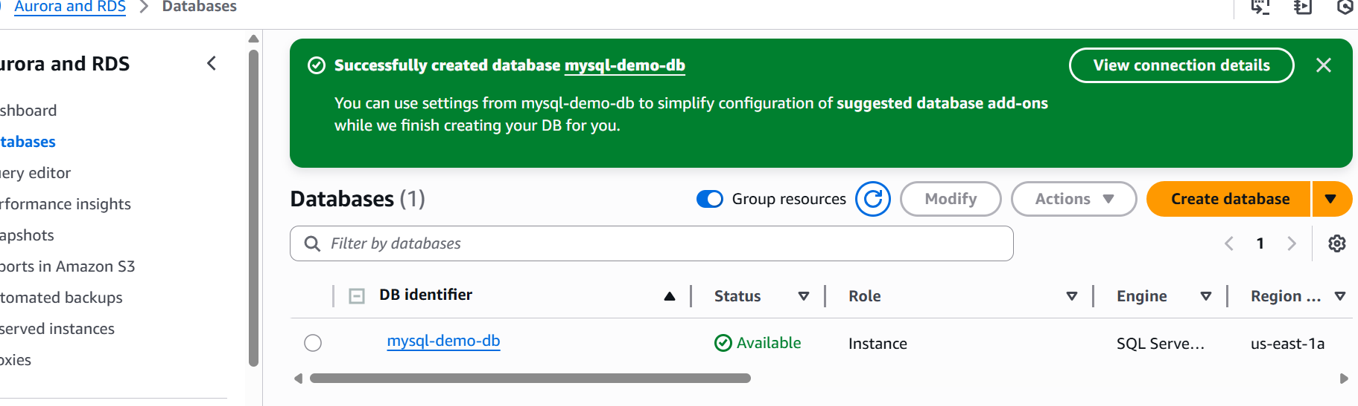
Steps to Connect AWS RDS SQL Server to SSMS
Step 1: Install SSMS (if not already installed)
- Go to: https://aka.ms/ssms
- Download and install the latest version.
- Launch SSMS after installation.
Step 2: Find Your RDS Endpoint
- Open AWS Console → Go to RDS
- Click on your SQL Server database from the list
- In the Connectivity & Security section
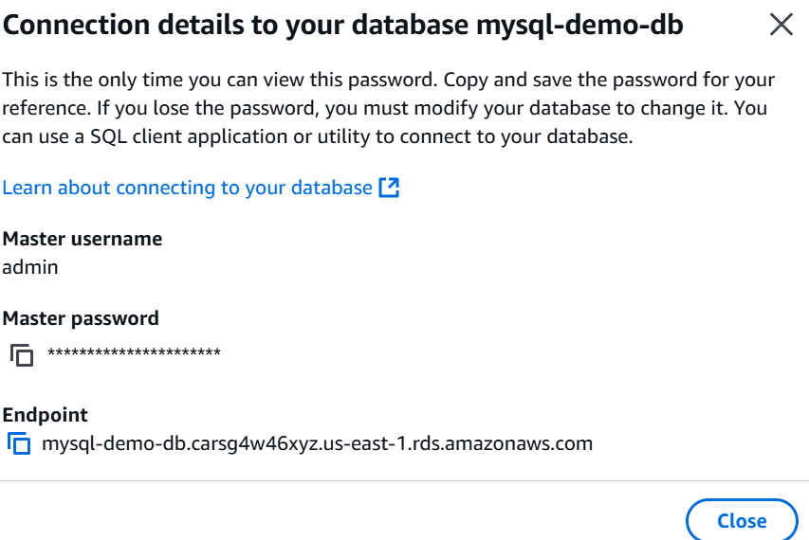
Step 3: Ensure Inbound Rule for Port 1433
- Go to EC2 > Security Groups
- Find and click the security group attached to your RDS DB
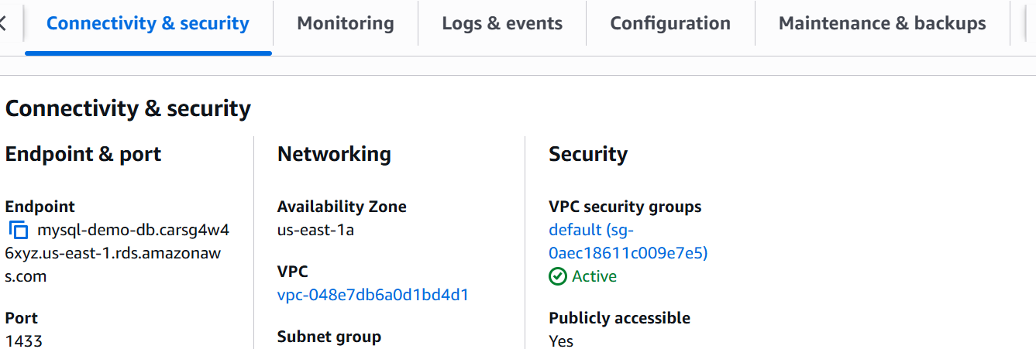
- Click the Inbound rules tab → Edit inbound rules
- Add a rule (if not already there):
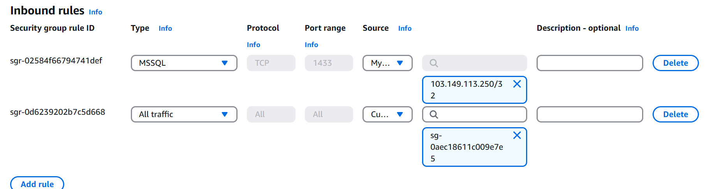
Step 4: Open SSMS and Connect
- Open SQL Server Management Studio
- In the Connect to Server window:
Server type Database Engine
Server name Paste your RDS endpoint (e.g., mssql-demo-db.abc123xyz.rds.amazonaws.com)
Authentication SQL Server Authentication
Login admin (or your master username)
Password Your master password
Click on Connect:
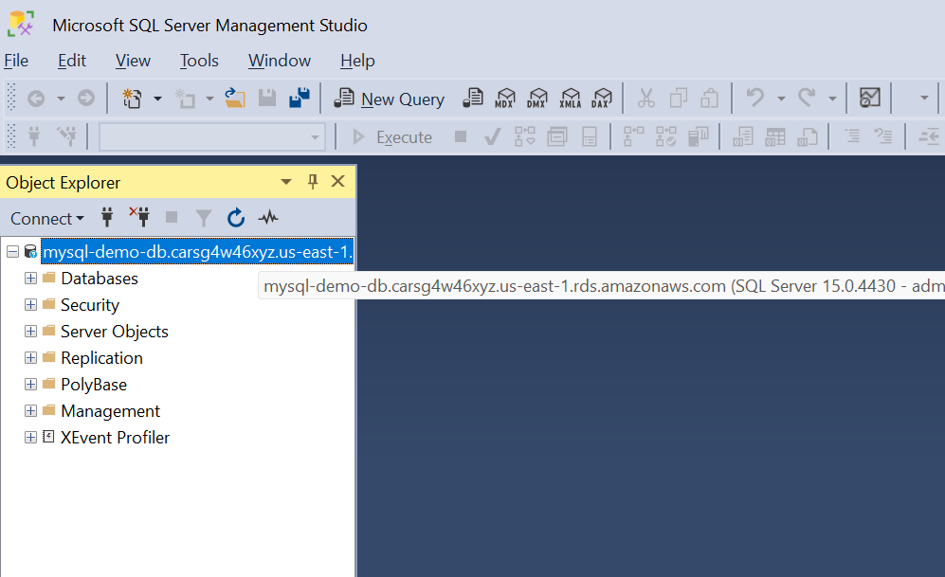
If Connection is Successful:
- You will see your SQL Server listed in Object Explorer
- You can now:
  - Create databases
  - Run SQL queries
  - Create tables, etc.
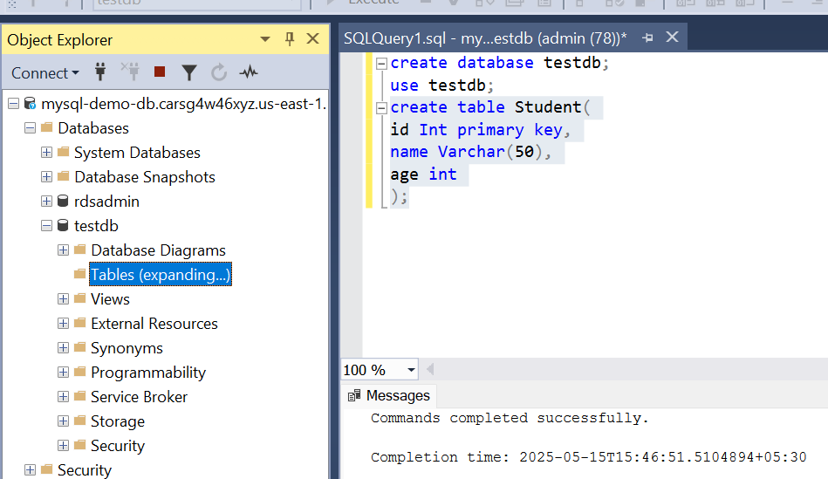
CREATE DATABASE testdb;

USE testdb;

CREATE TABLE students (
id INT PRIMARY KEY,
name NVARCHAR(50),
age INT
);

INSERT INTO students VALUES (1, 'John', 20), (2, 'Lisa', 22);
SELECT * FROM students;
